**Day 10 – Assignment**

**Statement 1 :-**

Most of the Males are leaving the Company ,

i.e about 62%

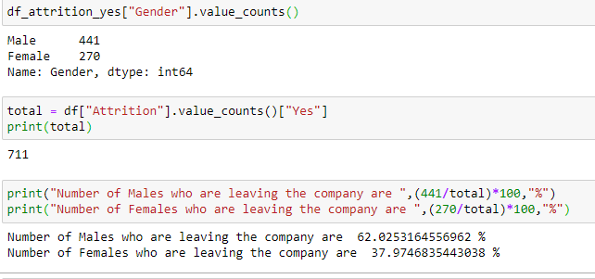

**Statement 2:** Mostly People are Leaving whose distance from home is less than 10

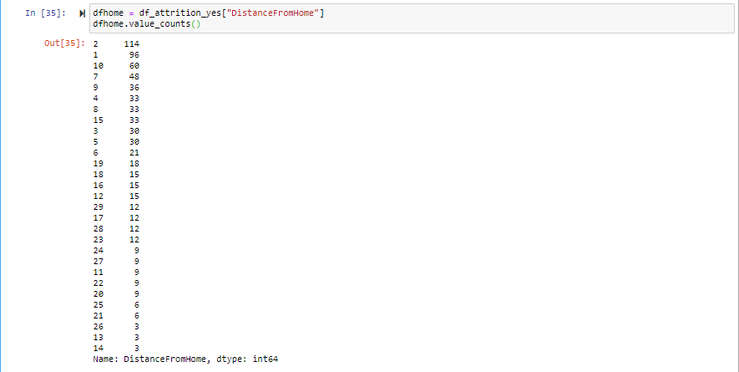

**Statement 3 :-**

Most of People from Research and Development, Sales Department are leaving

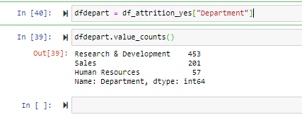

**Statement 4 :-**

People having Salary less than 60,000 have higher Attrition rate

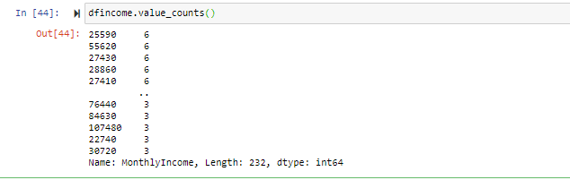

**Statement 5 :-**

People whose working years in company are <=10 have higher attrition Rate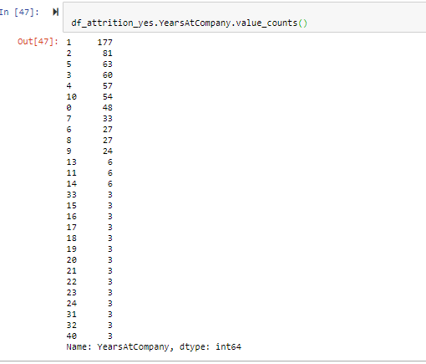

**Statement 6 :-** Most of employees from age group of 20-40 have higher attrition Rate

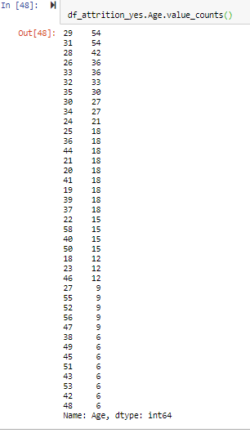

**Statement 7 :-** Average age of attrition population is 33

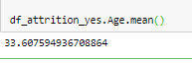

**Statement 8 :-** The employess who have job role as Sales Executive , Research Scientist, Laboratory Technician have Higher Attrition Rate

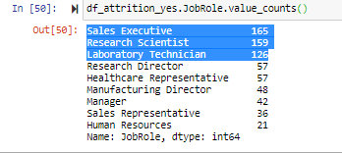

**Statement 9 :-** The People who are Single and Married have higher attrition Rate, Divorced people have lowest attrition Rate

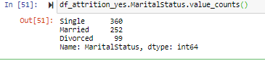

**Statement 10 :-**  Employess with Education Field **LifeSciences** and  **Medical** have higher attrition Rate